## GUI development for screw pump

In order to create GUI (Graphical User Interface) there will be required 2 things.

1. Data of Pump with different parameters
2. Software to Create a GUI

## Data of pump

Data that obtained from Pump Square LTD is look shown as below

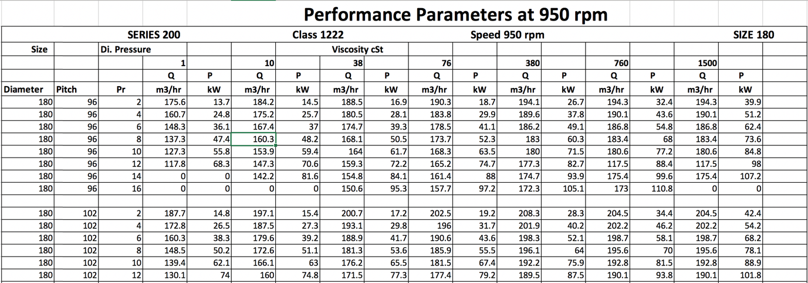

from this data we can extract following parameters

* Viscosity
* Pressure
* Speed
* Pitch
* Diameter
* Flowrate
* Power

Now require data is good enough data to create a Dataset , but Dataset have a problem as it can observe in some fields there are some missing values or some zero values and also data is not arranged in separate row so we need to clean up and arrange data.

## Cleaning up and arranging data

From original data it require create a separate column for each given parameters



After creating columns, Copy the respective data from original data sheets.

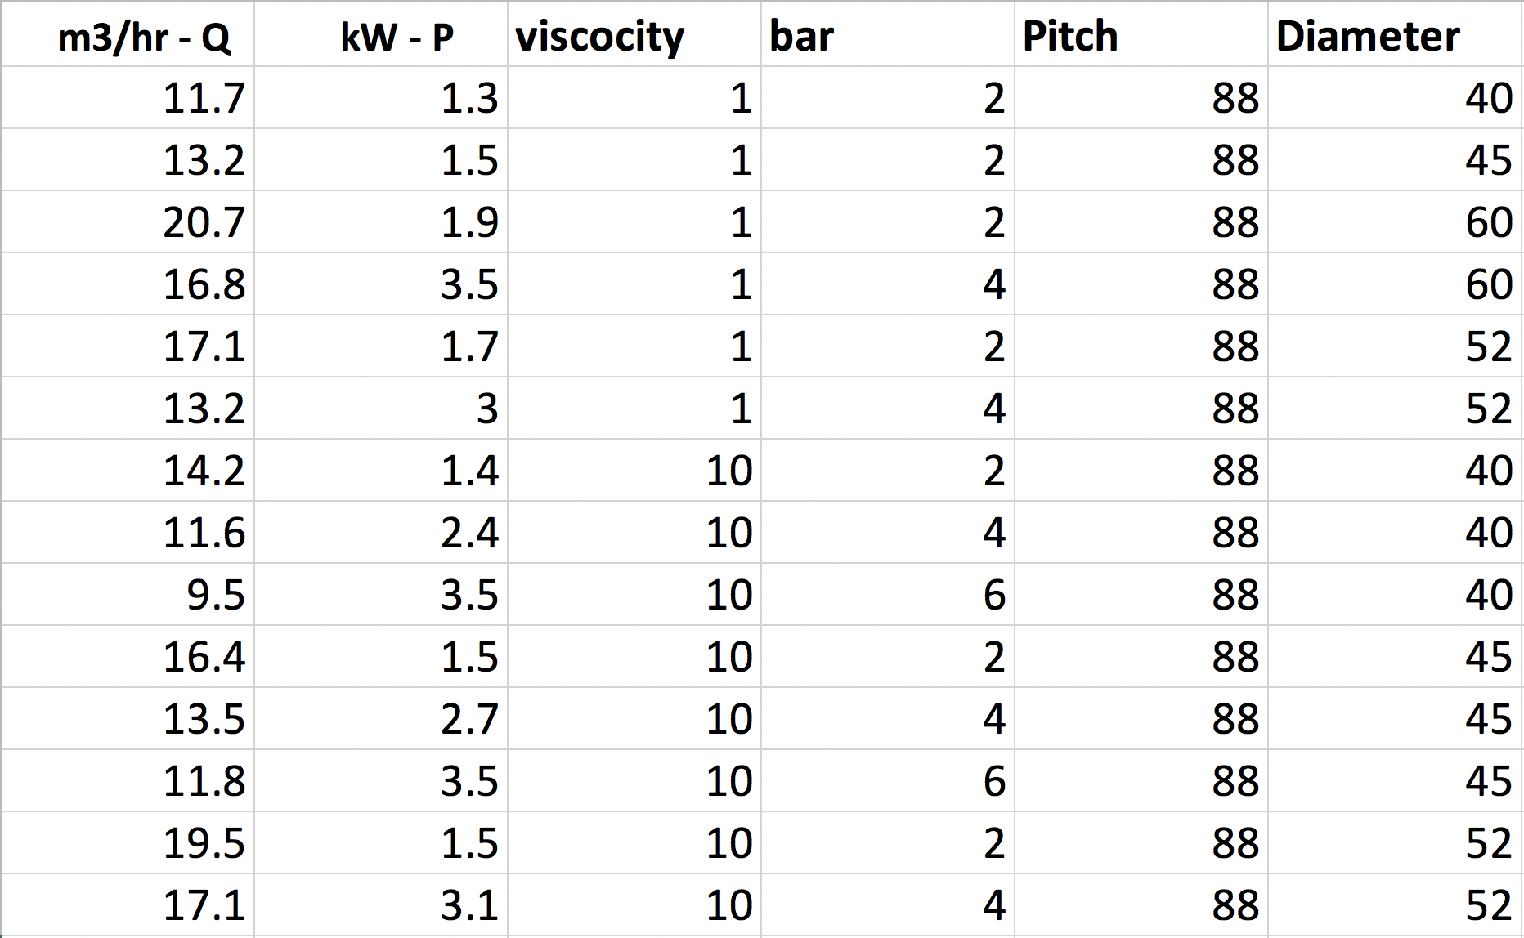

After arranging all the data it require to remove rows that containing no-data or zero value Then our database it ready to use in software.

## Software selection

Languages like Python or JavaScript but it will be difficult to create a without using any libraries so MATLAB is more suitable for this project.

# Reason behind choosing MATLAB

MATLAB is suitable to work with numeric data and good at preforming complex calculations and generating graphs. MATLAB also has a built in GUI Framework that is work on top of MATLAB programming language.

MATLAB has two GUI Frameworks,

1. GUIDE
2. Appdesigner

Appdesigner will be more suitable for this project.

## Reason behind choosing Appdesigner as GUI framework

Appdesigner is more suitable over GUIDE because Appdesigner is more efficient and newer and compatible with new operating systems.

Appdesigner work based on Object Oriented Programming(OOP) and OOP is very efficient , compact and organised. Another advantage of Appdesigner is it can compile the software for windows , mac , and also as a web application so it can run in browser.

# Appdesigner

App designer has two Views

1. Design View
2. Code View

In design view user can create a design of the software. Where user can simply drag and drop the components like input fields , Test Labels , Table , Container etc.

Code view is basically text editor with some predefined functions. Code view has main 3 sections.

1. Properties
2. Callbacks
3. Functions

Properties are used for defined global variables and for storing database data.

Callbacks are used for getting the user actions like input text value and or if have clicked button etc.

Functions are used for creating for some specific tasks that user is going to use over and over. Function take a value and returns Boolean , String , Integer , Void etc.

## Storing data in MATLAB

* Importing Excel data in MATLAB by “xlsread(‘/file/path’)” command.
* Assigning all data with their respective variable names as shown,

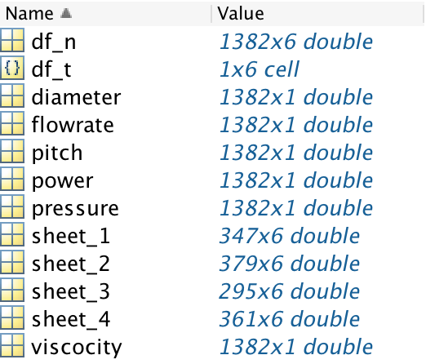

* Then saving all the variable values as “.mat” file by typing “save(‘data_sheet_all’,*)” command so it will be ready to use in Appdesigner.

## Creating GUI with Appdesigner

Form above process the database is ready to use in Appdesigner framework. So now It require to create Design of the software first.

## Design of the GUI

In this project It will require to have this components as shown below.

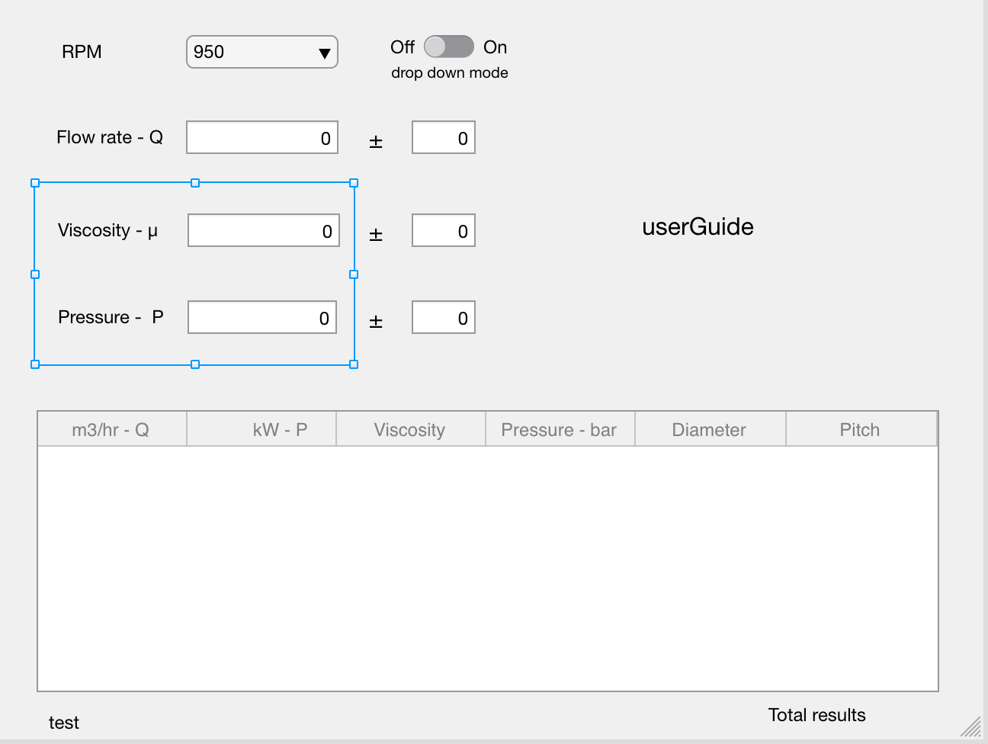

Required components in Design view

* Input Fields (Numeric)
* Drop Down Menu
* Label Text
* Table
* Container
* Toggle Switch

Code structure of GUI

Now by switching to “Code view” tab there will be a text editor and predefined callback functions this functions will run based on user interactions.

As initial step it is required to import Database from the “.mat” file. By Typing this command in property section,

data = load('data_sheet_all_mod.mat');

Database data will be imported to Appdesigner.

# Flow chart of the back-end code

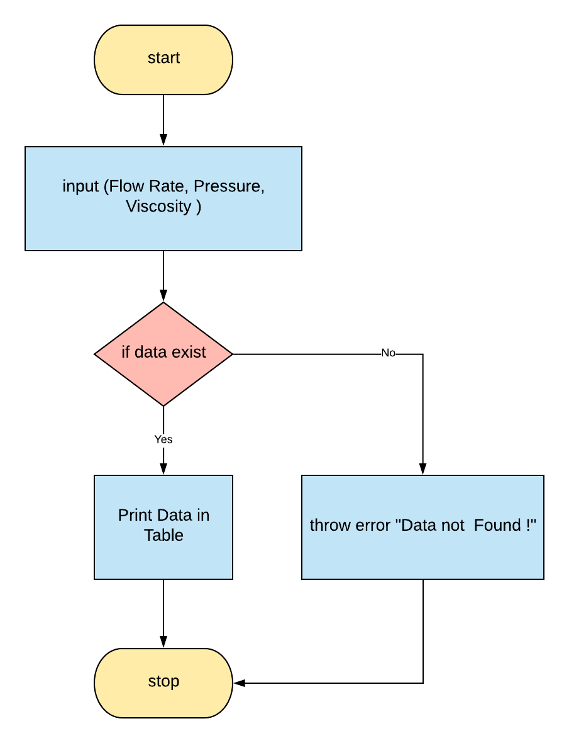

As per flowchart program should take those inputs and then query from the database and the need to check if data exits or not. If matching data has found then program should display data to the Table. If data dose not found then program should throw error that “Data is not Found !”.

# Writing the code according to Flowchart

* Callbacks will going to provide all user inputs from the input fields. It will return values of Flowrate , Viscosity, Pressure values respective to their callback functions. code structure is shown below,

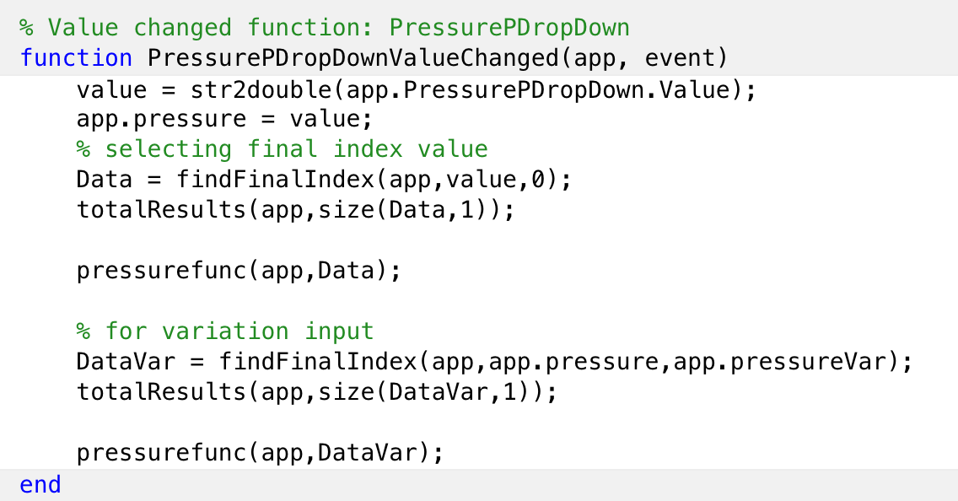

In all input callback functions all the values a are assigning into their respective variable names. In this case **app.pressure = value;** is a user input value from the user.

* Now it require to find a matching values from the database so it require to create a functions that able to find and returns a matching found data. In order to do that the code is shown below.

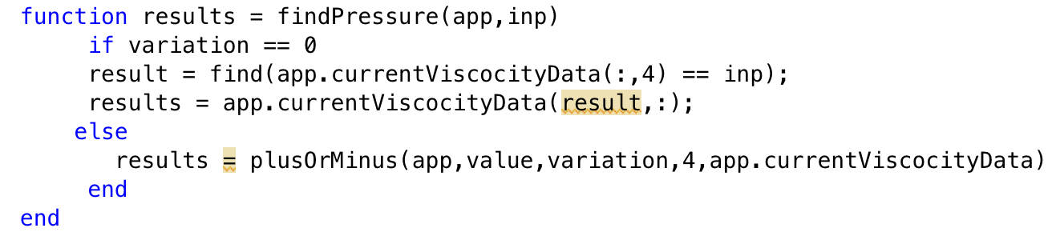

This functions will return all the matching results from the database and if there is length of the result is equal to 0 the functions will check for the variation fields (more info about variation fields will be in upcoming topic) and still if data is not found then function will return null object.

* For the variations input fields it is require to have a range of values in “find function” so here in this project there is “plusOsMinus” function as shown below.

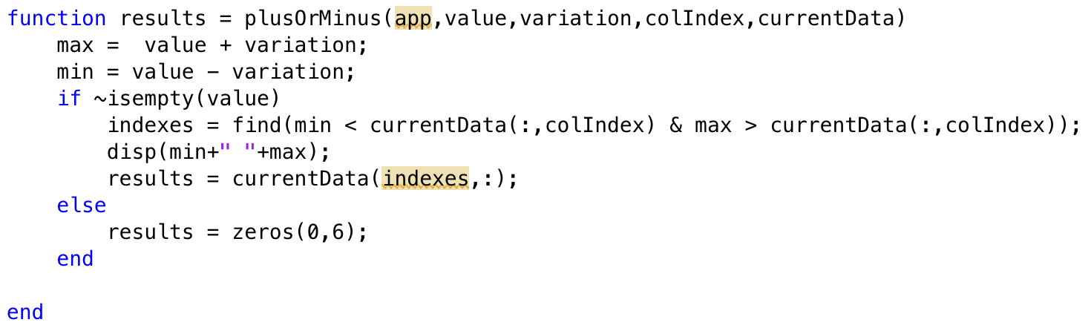

This function takes input value, variation , column index and current data from the variation it creates two variables “max” and “min” so now function will find values in rage of min and max variables. And it will returns all the numbers of results that has found in the range. If there is no result is found then it will going to return empty object.

* After filtering all the parameters there will final results are going to show in the table.
* There are also some additions features that have not mentioned here like drop down mode toggle switch and total results count function and error handling. from

# Creating Standalone program

After crating this whole software it is require to create a standalone program because most of the user’s computers will not going to have a MATLAB installed on their systems. So it is require to create a “.exe” for windows or “.dmg” for mac or “web application”.

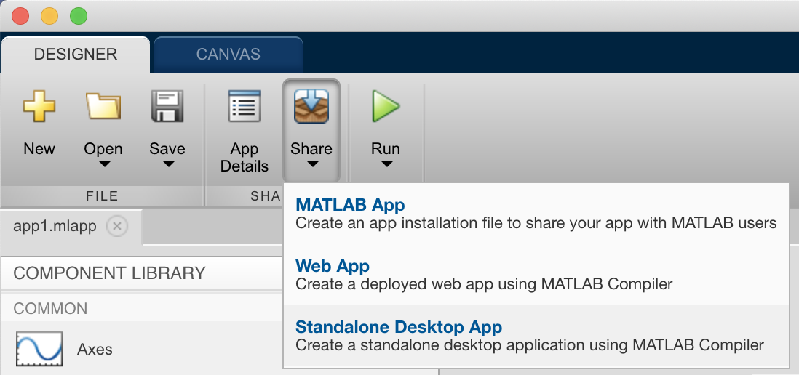

In Appdesigner there is a “applicationCompiler” the help to create a standalone program.

By clicking on the standalone desktop app and by following some steps there will be ready to install MATLAB app in their respective operating system.

Now there will be a folder “for_redistribution_files_only” in that folder there will be a executable file it can be able to run without requiring MATLAB in the operating system.

Here Is how final standalone program looks like.

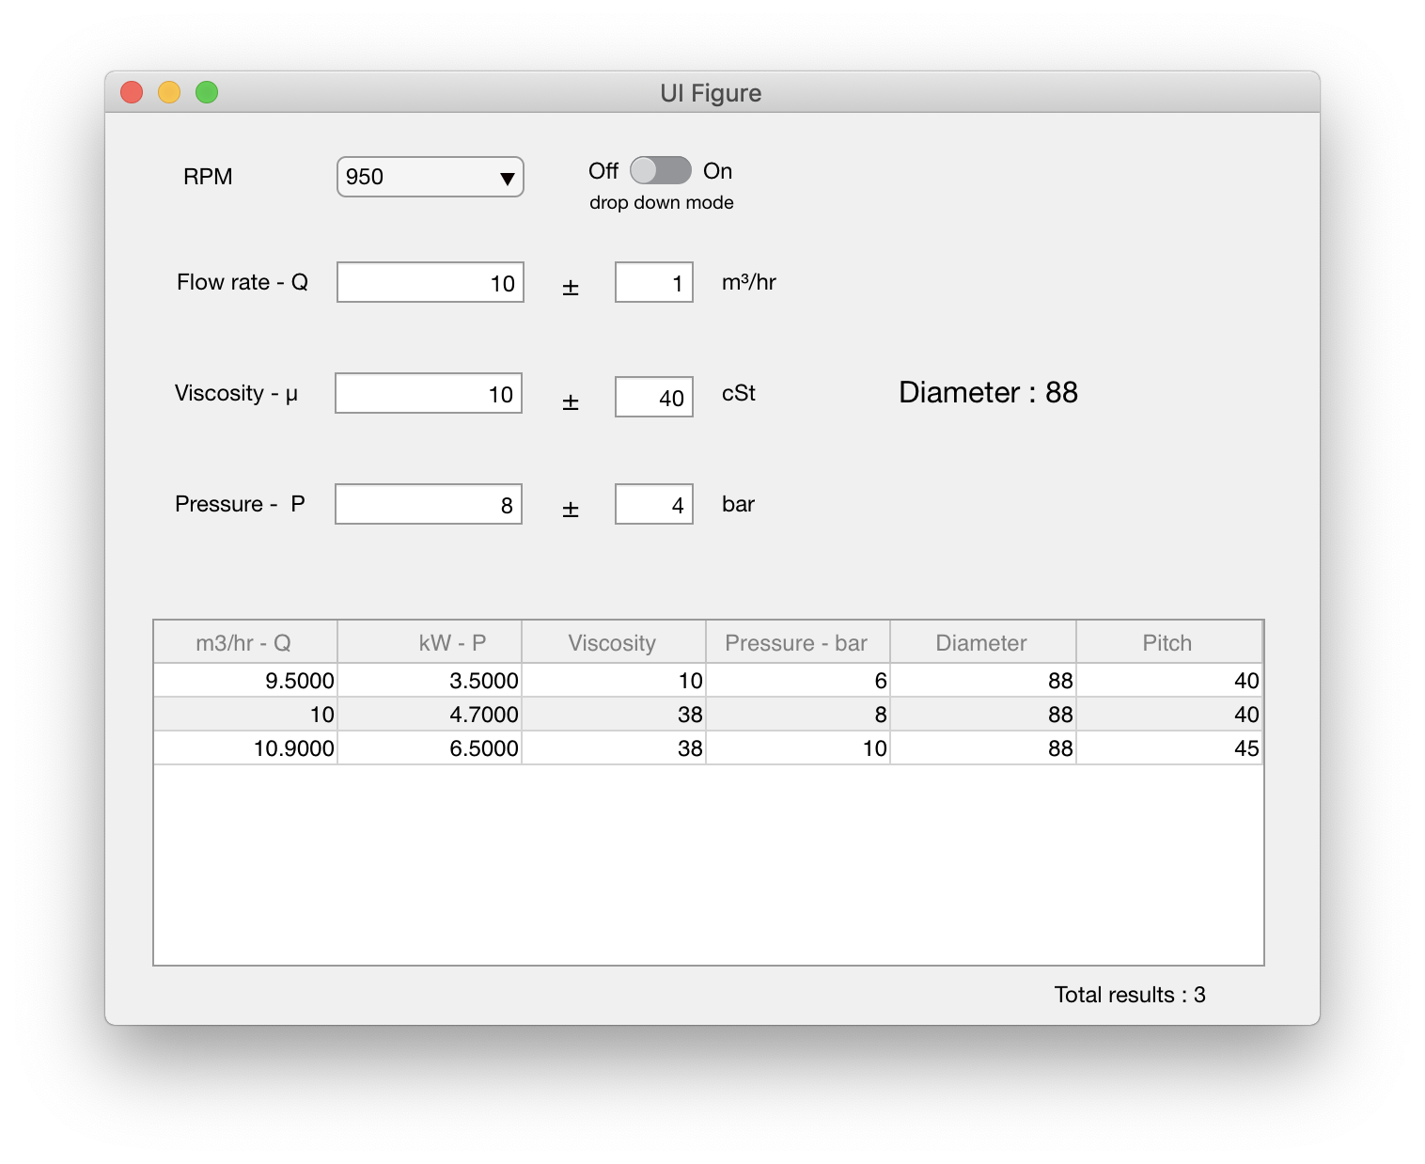

Conclusion

Our goal was to get the data from the excel sheet and create a dataset and to create a user friendly GUI software.

In this project we have created the stand alone software that takes user inputs as a pump parameters and filters the matching results from the dataset. This software can save good amount time without any errors. This software can handle large amount of datasets and also able to add new parameters in the dataset.

This software is user friendly so basically any one can use it , learning curve is very less.